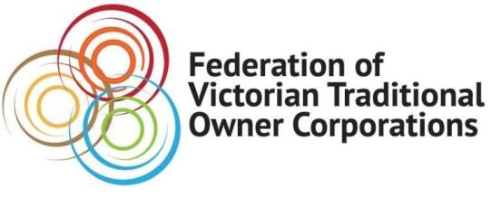
MEDIA RELEASE
Monday 29 November 2021

TRADITIONAL OWNERS TO HELP SHAPE NATIONAL PROTECTION LAWS
Strong, national laws to protect First Nations cultural history have been welcomed by the Federation of Victorian Traditional Owner Corporations.
As a member of the First Nations Heritage Protection Alliance, the Federation lauded today’s historic partnership between the Federal Government and the Alliance in a bid to create national standards across Aboriginal Cultural Heritage laws.
Victorian Traditional Owner voices would be heard as part of the partnership, which will see the establishment of a 12-month consultation program across the nation to build the framework for the new laws.
The agreement also sees Traditional Owners working with the Victorian Government to ensure laws are robust and remain grounded in evidence through a collaborative approach.
The Alliance, a national body consisting of Aboriginal leaders from across Australia representing Aboriginal Land Councils, Native Title Representative Bodies and Aboriginal and Torres Strait Islander Community Controlled Organisations, have long called for the Federal Government to introduce national standards based on the United Nations Declaration of the Rights of Indigenous People following the 2020 destruction of Juukan Gorge by mining giant Rio Tinto.
The Alliance called for the laws to be based on the principles of empowerment of Aboriginal and Torres Strait Islander people to make decisions on our own cultural heritage, self-determination, First Nations decision making, greater transparency and free, prior and informed consent.

ENDS

QUOTES ATTRIBUTABLE TO
Paul Paton, CEO, Federation of Victorian Traditional Owner Corporations:
“Our people have lived on, and maintained a connection to, Country for some 65,000 years.”
“As Traditional Owners we have the knowledge to protect our sacred sites and areas of significant cultural heritage and now we need the laws to enable us to fulfil our responsibilities.”
Rodney Carter, Chairman, Federation of Victorian Traditional Owner Corporations and CEO Djaara:
“Traditional Owners are best placed to protect and care for their Cultural Heritage sites.”
“That’s why it’s important to raise our voices and work together to build the strongest laws we can to protect our heritage for future generations.”

For more information about this Media Release: Madison West 0433 583 011 or email mwest@porternovelli.com.au

