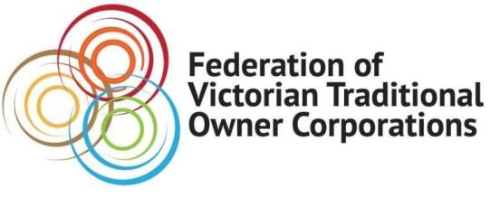
MEDIA RELEASE
Wednesday 20th October 2021

TRADITIONAL OWNERS WANT TO SELF-DETERMINE HOW TO BEST PROTECT CULTURAL HERITAGE
Traditional Owners must be in charge of protecting and preserving their unique cultural heritage across Victoria.

The Federation of Victorian Traditional Owner Corporations has called on the Victorian Government to follow the lead of its Federal Labor colleagues and accept recommendations that will enable Traditional Owners to self-determine the way their valuable history is preserved.

The call comes on the release of the A Way Forward report from the Joint Standing Committee on Northern Australia, a final report into the destruction of Indigenous heritage sites at Juukan Gorge.

This week the three Labor members of the Joint Standing Committee urged the Federal Government to support the recommendations coming out of the inquiry into the destruction of 46,000-year-old Juukan rock shelters in Western Australia by mining giant Rio Tinto. Similarly, in Victoria over the past decade there have been many instances of significant cultural sites being damaged, causing great distress to Traditional Owners.

The Juukan Gorge report calls on the Commonwealth to set minimum standards for state and territory protection laws, give Traditional Owners the powers to stop destruction of cultural heritage and to co-design the heritage protection legislation with First Nations people.

The latest report echoes a similar report released on 4 October by the Victorian Aboriginal Heritage Council, entitled Taking Control of Our Heritage, which identified the lack of self-determination for Traditional Owners over their unique cultural heritage.

Both reports recommend that the United Nations’ Declaration on the Rights of Indigenous Peoples underpin stronger laws to protect First Nations cultural heritage.

Victorian Traditional Owners have long argued that the current Aboriginal Heritage Act 2006 often left them traumatised by the destruction of cultural heritage.

The Federation urged the Victorian Government to strengthen the Act to meet the changing international standards and maintain Victoria’s place as the state or territory with the strongest laws in Australia.

The Federation of Victorian Traditional Owner Corporations said further conversations with Traditional Owners needed to be held to work through issues on how the VAHC operates.

The report, handed to Victorian Aboriginal Affairs Minister Gabrielle Williams on Monday 4 October, was prompted in June 2020 by the release of the Taking Control of our Heritage Discussion Paper, also by the Victorian Aboriginal Heritage Council, and the Community consultations, submissions and further consultation which followed.

For more information about the Federation of Victorian Traditional Owner Corporations and Taking Control of our Heritage report, please visit https://www.fvtoc.com.au/
ENDS

QUOTES ATTRIBUTABLE TO
Paul Paton, CEO, Federation of Victorian Traditional Owner Corporations:
“This report into the Juukan Gorge disaster is an opportunity for all Australian Governments to show leadership in protecting First Nations’ cultural heritage.”
“Just like the report into the Victorian heritage protection system, this report identifies significant shortfalls across all jurisdictions into how Traditional Owners manage, protect and preserve their sacred sites and artefacts.”
“It is time to accept Traditional Owner cultural heritage is important to the entire community.”
Rodney Carter, Chairman, Federation of Victorian Traditional Owner Corporations:
“There have been seismic changes in the way the non-Aboriginal community views and appreciates the way Traditional Owners care for Country and that includes our sites of cultural significance,”
“Self-determination is more than a buzz word, it’s an opportunity for Traditional Owners to continue to exercise their rights, responsibilities, knowledge and voices to protect the legacy of previous generations.
“As members of the oldest living culture in the world, Traditional Owners are best placed to take care of our cultural heritage for future generations.”

For more information about this Media Release: Madison West 0433 583 011 or email mwest@porternovelli.com.au

