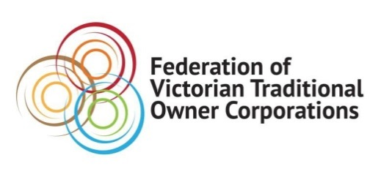
Media Release

LAUNCH OF VICTORIAN TRADITIONAL OWNER CULTURAL FIRE STRATEGY SIGNALS NEW ERA FOR POLICY DEVELOPMENT
Monday 13 May 2019
The Victorian Traditional Owner Cultural Fire Strategy has officially been launched. It’s the first of its kind.
The landmark document is a culmination of two years of hard work and thousands of years of knowledge and wisdom from Traditional Owners across the Victoria.
The document provides a set of principles and strategic priorities to facilitate greater self-determination for Traditional Owners and provides a policy and practice framework for effective Traditional Owner-led cultural fire management in Victoria.
Wurundjeri Elder Dave Wandin, who was one of the key Indigenous fire practioners involved in the development of the strategy, spoke to its importance at a ceremony at Nioka Bush Camp on Friday.
“As we start to document now, as we must do, our practices I believe it will change the scientific model of how fire has been handled in the past,” he said.
“It is about forgetting our borders and caring for Country as a whole … cultural fire means everything. It means healing Country and when you heal Country, you heal people.”
The strategy will help provide a policy directive and framework across Victoria’s fire agencies to support Traditional Owners to reintroduce cultural fire for the range of cultural values entailed by caring for Country.
Federation of Victorian Traditional Owner Corporations CEO Marcus Stewart said the significance of this project was that it forged a new way of thinking and partnership between Traditional Owners and government.
“First and foremost, I would like to acknowledge the Fire Knowledge Holder Group for their time, expertise and dedication, but also my team for their hard work in supporting the Fire Knowledge Holder Group through this process.
“The reason this strategy is so unique and meaningful is because it’s Traditional Owner led. The state government has been incredibly supportive in enabling this approach for Traditional Owners to share their aspirations around cultural burning.
“This approach has provided a pathway to reinvigorate and embed fire knowledge and practices across Victoria.”

For further comment or information on the Strategy please contact Alexandra Sheehy on 0420 314 221.
Federation of Victorian Traditional Owner Corporations
PO Box 431, North Melbourne VIC 3051
t: (03) 9321 5300 | Toll Free: 1800 791 779 | f: (03) 9326 4075
Website: www.fvtoc.com.au
We acknowledge the Traditional Owners of the land we work on as the First People of this country.

