UNCLE GRAHAM ATKINSON, ANZAC DAY 2018
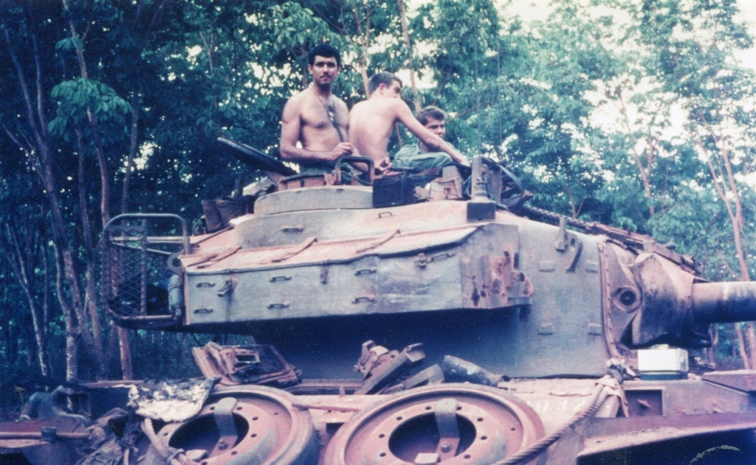

Vietnam Veteran and Aboriginal Elder Graham Atkinson while on duty at Nui Dat in South Vietnam.

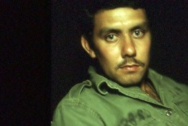
Graham Atkinson is a Dja Dja Wurrung and Yorta Yorta Elder and an untiring advocate for Traditional Owner groups and his people. Graham is also a Vietnam Veteran, having served in South Vietnam from 1969-1970 as part of National Service training during 1968-1970. In 1995, the National NAIDOC Committee selected Graham as the National Scholar of the Year for attaining his MBA through part-time study in 1994. In 2001, Graham was awarded the Centenary Medal. He was a state finalist for Senior Australian of the Year in 2013. A highly respected role model, Graham remains as committed as ever to enacting positive change to help build a better society for his people and the community. Graham is a community leader committed to social justice and empowering individuals.

Words by Graham Atkinson:

As an Indigenous Vietnam Veteran I recognise ANZAC Day not as a day to glorify war, but to pay respect to the men and women who gave their services to Australia in the wars and conflicts that are now part of Australian history. ANZAC Day, for me, is largely about respecting and acknowledging the sacrifice men and women made representing their country.

It is important to me because as an Indigenous veteran this day gives a timely recognition and pays tribute to all Aboriginal and Torres Strait Islander men and women who served their country in the great wars, and have made tours of duty in Korea, Malaysia, Vietnam, East Timor, the Middle East, Iraq, Afghanistan and other areas since.

People feel more comfortable to ask me about my Army and Vietnam experience now. Until very recently many Veterans, myself included, didn’t feel the need to talk about it, and would often move the conversation to another topic. Most service people would still relate to this no doubt. Times have changed and I feel much freer to talk about it now and that is a good thing. The other positive development here is that I now participate in the ANZAC Day March along with my sons who are proud to march with me through the city to the Shrine of Remembrance.

My experiences overseas were mixed and I mention these in various interviews I’ve done. While I found war to be a surreal experience in many ways, I would say that my army experience transformed my life in many different ways. For example, I managed to build on learning opportunities that came my way; during my army experience I resumed and later completed my education which allowed me to complete further tertiary studies once I left the army.

War also has a dark side which leaves lingering memories that take time to heal during the lengthy recovery process that many service people experience after they are discharged from the army. While I am pleased to say there is great work being done through Veteran’s Affairs and other groups to support people returning from active service, still more needs to be done, and the needs of returning soldiers should never be ignored.

I made mention of many challenging times in a short DVD that I made at the Australian Centre for the Moving Image with Dot Peter’s group in 2010. Overseas service in a war zone triggered many feelings, some instinctive, and others like a sense of estrangement or disconnection from our place of belonging and loved ones. However, we learned to adapt the best way we could. The greatest strength in the army is the comradeship among soldiers, especially when the chips are down.

Coming from a big, strong Aboriginal family equipped me with the strength and persistence to deal with anything that was thrown my way. In fact I took advantage of a difficult situation to better my skills, both during active service and then after I was discharged from the army. I didn’t brood over or resent my experience, but more or less took it in my stride.

I want finish off by saying that let’s not forget the role that our families, loved ones, friends and descendants of Indigenous servicemen played back in Australia. It is the support from the loved one’s of service men and women that helps in trying times when on overseas duty that makes a big difference. I will always remember the letters I used to get from my family about news from back home that helped to lift our morale in challenging circumstances. Their love and support never goes unappreciated.

Now there’s an increasing trend for other Indigenous Veterans like me to use the day to tell our story of our experiences, both good and bad, and that is a great thing.

