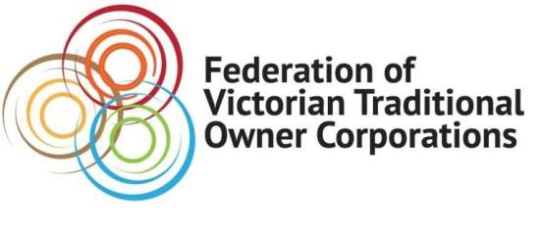
MEDIA RELEASE
Tuesday 5 October 2021

NEW REPORT CALLS ON VICTORIAN GOVERNMENT FOR STRONGER POWERS FOR TRADITIONAL OWNERS TO PROTECT CULTURAL HERITAGE
The Federation of Victorian Traditional Owner Corporations has backed a report calling for stronger Cultural Heritage protection laws that will enable Traditional Owners to self-determine the way their valuable history is preserved.

The Federation is supportive of member organisations’ calls for the stronger rules, acknowledging the current Aboriginal Heritage Act 2006 often left Traditional Owners traumatised by the destruction of Cultural Heritage.

The Federation called on the Victorian Government to adopt the recommendations in the Taking Control of our Heritage report, to ensure Victoria’s laws around protecting Cultural Heritage for Traditional Owners meet the changing international standards and maintain Victoria’s place as the state or territory with the strongest laws in Australia.

The Federation of Victorian Traditional Owner Corporations is also supportive of wider recommendations from the Victorian Aboriginal Heritage Council to further self-determination for Registered Aboriginal Parties and for the choice to promote candidates for the heritage council.

The report, handed to Victorian Aboriginal Affairs Minister Gabrielle Williams on Monday 4 October, was prompted in June 2020 by the release of the Taking Control of our Heritage Discussion Paper, also by the Victorian Aboriginal Heritage Council, and the Community consultations, submissions and further consultation which followed.

The report includes an overwhelming racist consideration that First Peoples could not responsibly undertake the functions of the Act.

For more information about the Federation of Victorian Traditional Owner Corporations and Taking Control of our Heritage report, please visit https://www.fvtoc.com.au/
ENDS

QUOTES ATTRIBUTABLE TO
Paul Paton, CEO, Federation of Victorian Traditional Owner Corporations:
“There is enormous and calculated loss happening across Victoria through inappropriate development planning on Country.”
“By adopting these recommendations outlined in the Taking Control of our Heritage report, the Victorian Government is committed to ensuring Victoria has the best legal protection for Traditional Owners Cultural Heritage and continues Victoria’s nation-leading work.”
“These reforms must be adopted, to bring about profound, positive change for protection, management and lived engagement with our Cultural Heritage.”
Rodney Carter, Chairman, Federation of Victorian Traditional Owner Corporations:
“For too long, Traditional Owners have had to watch the destruction of Cultural Heritage in Victoria because their capacity to stop harm is so limited.”
“The way Traditional Owners’ rights, responsibilities, knowledge and voices are considered and appreciated by non-Aboriginal Victorians mean changes are needed to strengthen Cultural Heritage protection legislation.”
“Self-determination of Traditional Owner Cultural Heritage is underpinned by the United Nation’s Declaration on the Rights of Indigenous Peoples and we are calling for the Victorian Government to commit to the Declaration in its full capacity and align with international standards.

For more information about this Media Release: Madison West 0433 583 011, email mwest@porternovelli.com.au

